Parihaka 2022
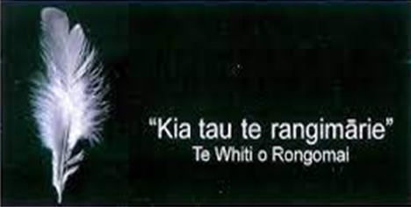
This year, we once again commemorate Parihaka, during the season of peace.
You are warmly invited to join us for a dawn ceremony: 7 am, November 5th at the Rongo Stone on Anderson’s Bay Road.
We also invite you to join us in some activities planned to mark the season of peace (outlined below).
During this season, we remember some of the big stories relevant to us in Aotearoa, including Parihaka, Pai Mārire, Armistice​, Rā Maumahara – National Day of Commemoration of NZ Land Wars, and Archibald Baxter. These pūrakau, ancestral stories, can challenge/inspire us to respond in a personal and creative way​.​
Let us consider again these important themes of peace, justice, separation, loss of land, peace in a troubled world, and hope. Naumai, haere mai koutou!

Activity | Where | What | Time
Garden visit (1) | 292 Helensburgh Road  Frazer + Sarah Barton | Restoration Project (wear shoes suitable for steep, rough tracks) | Sat Nov 5th, 2 - 3.30 pm
Service of Worship | Flagstaff Community Church  9 Centennial Avenue | Remembering Parihaka | Sun Nov 6th, 9.30 am
Vigil for peace | Knox Church, George Street | Parihaka Memorial Vigil | Sun Nov 6th, 7.00 pm
Garden visit (2) | 32 Honeystone Street:  Sue + Alastair Yule | Spring Beauty | Fri Nov 11th,10 am - 4 pm
Lecture by Peter Matheson followed by a hīkoi to Conscientious Objectors’ Memorial and short vigil. | Holy Name Church, Great King St - Peace Garden, George St | Archibald Baxter + conscientious objectors | Fri 11th Nov 7.30 pm
Poetry | Flagstaff Community Church  9 Centennial Avenue, Dunedin | Te Reo Rongo: Tom Mepham | Sat Nov 12th, 12.30- 2 pm
Creative Arts / Journaling |  | Hautaka Rongo: Kat Taiaroa | Sat Nov 12th, 1.00 - 3 pm
Wreath making |  | Mahi Toi: Sue Walthert | Sat Nov 12th, 1.30 - 3.15
These activities have been made possible by funding from The Synod of Otago & Southland.
Any enquiries contact Brendon McRae: 027-3569200
A koha will be taken which will go towards Dunedin Night Shelter

