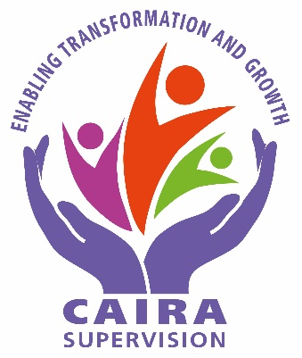
ENROLMENT FORM
I wish to enrol in the CAIRA course to be held in Balclutha in 2023

Name: …………………………………………………………………………
Address: …………………………………………………………………………..
..……………………………………………………………………………
………………………………………………………………………………
Email: ………………………………………………………………………………
Phone: ……………………………………………………

Preferred Day of the Week for the Course: Tick your availability
Thursday
Friday
Saturday

Please send completed forms and support to Jenny Campbell at jennycam@xtra.co.nz by 1st November, 2022

