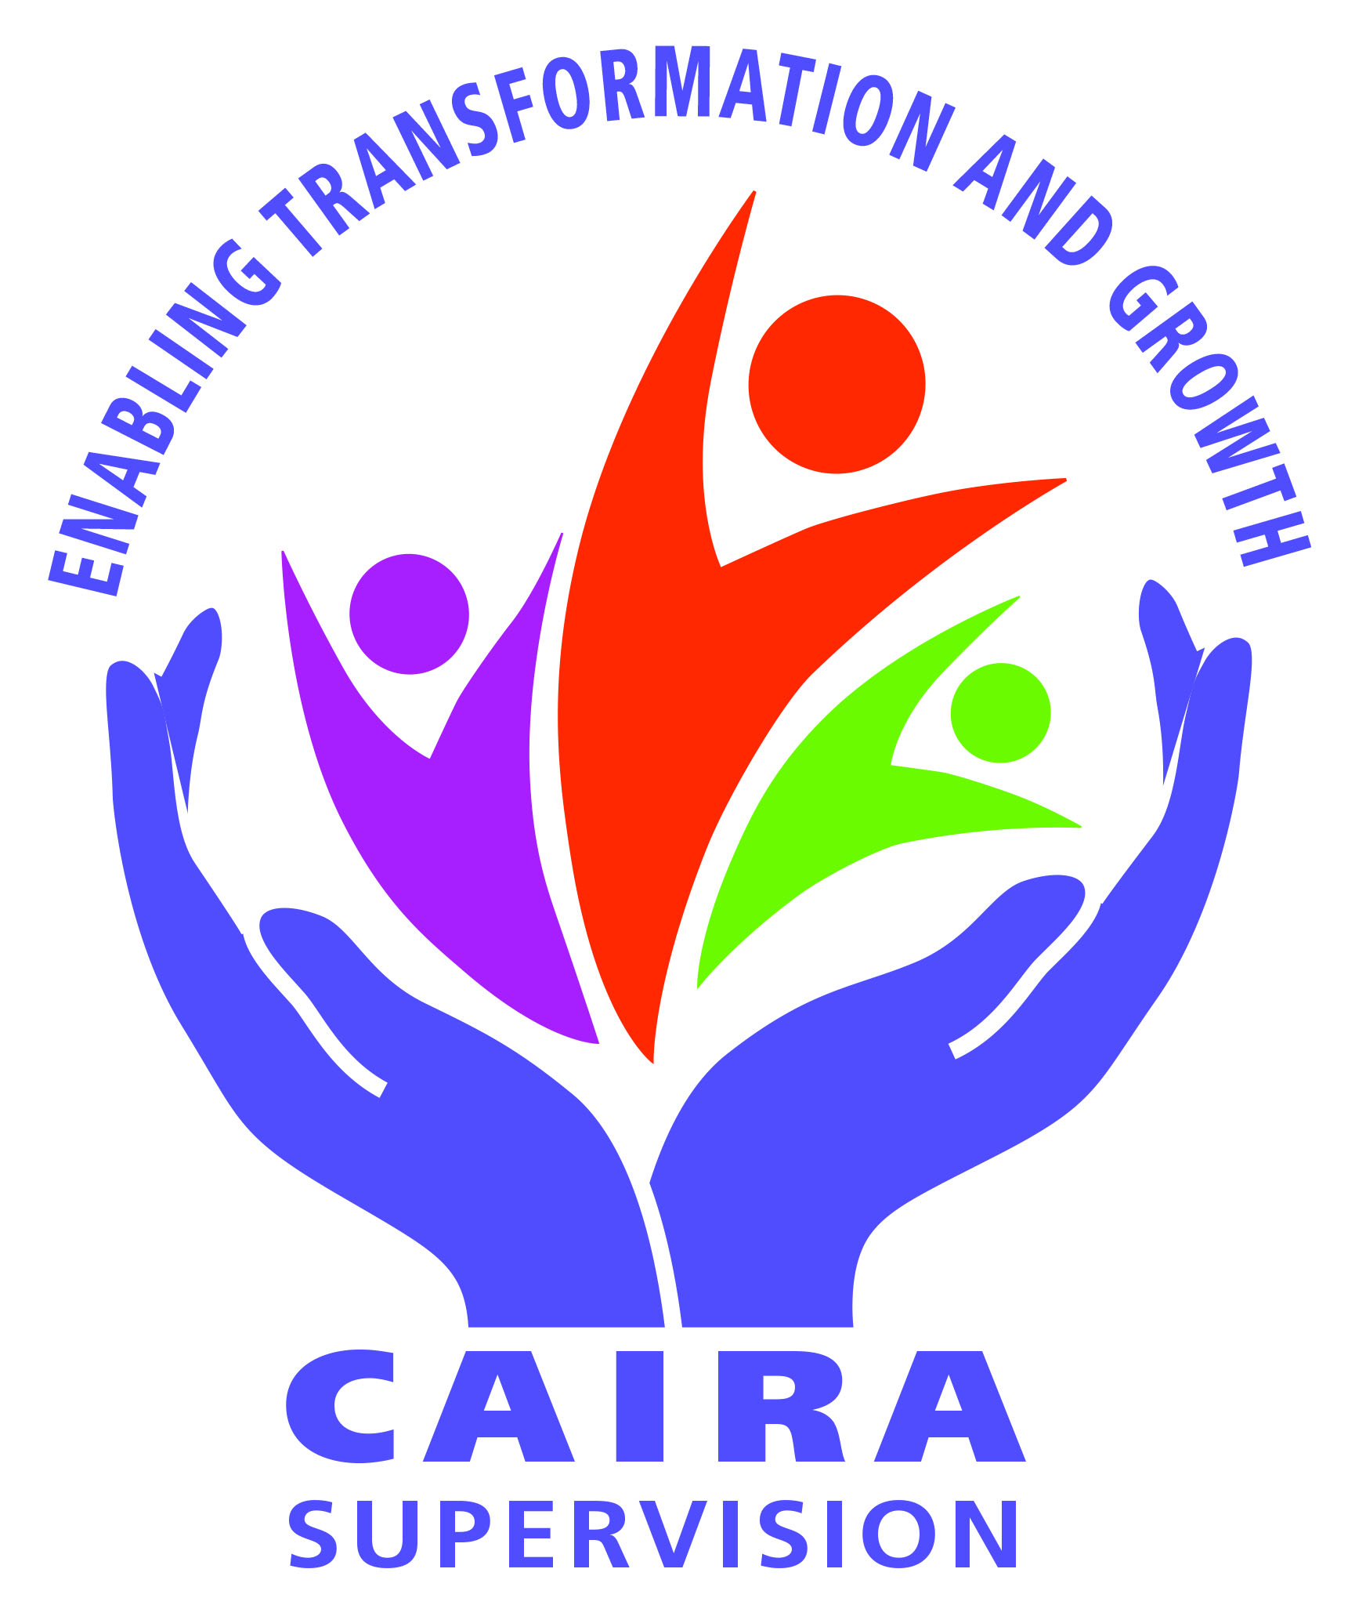
Collegiality, Accountability, Identity, Responsibility, Authority
17/10/2022
To Churches and community groups offering pastoral care in the Otago/Southland region.
Whakataukī:- Titiro whakamuri, kōkiri whakamua
Look back and reflect so you can move forward.
CAIRANZ is an organisation originally founded within the Anglican Church of Aotearoa New Zealand and Polynesia to provide professional training for those interested in becoming Pastoral Supervisors. The course is now ecumenical, with previous attendees from Anglican, Methodist, Presbyterian, Catholic, Pentecostal, Salvation Army, Baptist Churches and other community groups doing pastoral work.
Most pastoral care organisations now require their clergy/pastors and those working in ministry with children, youth, and vulnerable people to meet regularly with a trained supervisor. There is presently a shortage of trained supervisors in this region and so we have been asked to provide this training.
The course works on a model of experiential learning, and valuing the knowledge and experience participants bring with them. Before potential trainees commit to the course, we ask them to attend a ‘Taste and See’ session on Saturday 12th November 2022 at 1.00pm at St Mark’s Anglican Church, 19 Renfrew St., Balclutha.
Requirements for those offering themselves for training are as follows;
- Prospective trainees to attend a ‘Taste and See’ session.
- Following the ‘Taste and See’ meeting, those interested in enrolling in the training course are asked to submit a short piece of written work describing their background and interest in becoming a CAIRA supervisor.
- Those accepted will undertake a course of 20 modules presented over 20 sessions, with CAIRA trained facilitators. This will occur over two years, meeting monthly with the other trainees for 5 hours. As well some preparation, reflection and practical work will be required in trainees’ own time. The day of the week will be negotiated with potential trainees. We hope to begin the first module in February, 2023.
- Trainees should ideally have experienced supervision or intentionally commit to having supervision.
- The cost of the course is $750. There may be some funds available to assist people who find this difficult to meet, through CAIRA, churches or other workplaces.
- On completion of the training, graduates are admitted as Members of the professional community of CAIRANZ supervisors, which requires an annual renewal of their licence.
CAIRA welcomes people as supervisor trainees from all Christian denominations and professions involved with helping others.
Please would you bring this letter to the attention of anyone (lay or ordained) on your staff, in your congregation or others from associated pastoral/ helping agencies who may be interested in training for this ministry.
Replies please, by Tuesday 1st November 2022 to:
Jenny Campbell, email: jennycam@xtra.co.nz
Rev Lee Kearon, lee.kearon@gmail.com
Thank you for taking the time to read and consider this ministry opportunity.
Check out our website www.caira.org.nz
Rangimarie and blessings

Jenny Campbell (Member CAIRANZ) Rev Lee Kearon (Member CAIRANZ )

Supported by CAIRA National Coordinator, Rev Marilyn Welch, MCAIRANZ

